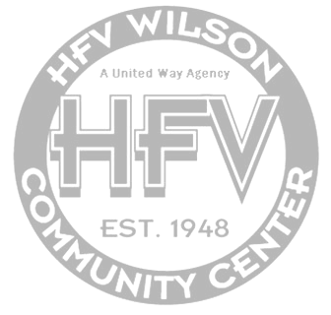

Martin Luther King Jr Scholarship 2023

Deadline February 21, 2023
Dear Applicant:

The H.F.V. Wilson Community Center is pleased to have you as an Applicant for our Dr. Martin Luther King Jr. Scholarship. Your application and all supporting documents must be turned in no later than February 21, 2023.

APPLICATION: Fill out the form completely and carefully.
Both you and a parent or guardian must sign this application.

ATTACHMENTS: Please check attachments as needed:

__ Letter of Admission from the college/trade you will be attending/ Major intended (if applicable)

__ Two Character Recommendations on their letterhead
(pastor, teacher, counselor, principle, employer, etc)

__ Volunteer opportunities and hours

__ High School Transcript

__ ACT/SAT Score (if applicable)

__ Scholastic and/or Athletic Awards received throughout educational years (if applicable)

__ 500 word max Personal statement

__ Parent/Guardian monthly income

__ 500 word max Essay (writing prompt below)

As we navigate through life we come across people who impact our lives for the better.There are many individuals who have the strongest impact in our lives. Are they your role model? These can be your family members, friends, or a public figure. What person do you admire most? What role do they play in your life? How has it shaped who you are as a person?

Any questions you may have can be directed to JaMia Cody, Executive Director of the Community Center at 580-319-5350.

NOTE: Deadline for accepting applications will be February 21st at 5pm. Each applicant must submit the entire application with signature and other necessary documents by the deadline to be considered for the program. The scholarship will be presented on the 26th of February at HFV Wilson Community Center’s Black History Month Celebration at 5pm. The scholarship recipient will need to be present to be presented the scholarship.

Mail application packet to:
H.F.V. Wilson Community Center
Attention: Executive Director
P.O. Box 502 Ardmore, OK. 73402

