- Click on this link SKPMF Scholarship Application Form (you will have to forward this email to keep this link embedded with the application web site address)
- Scan the QR code on any mobile device with a camera, which will populate a link on their phones
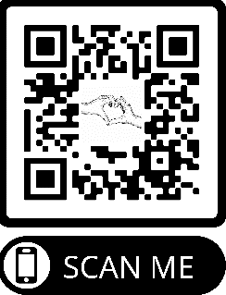
- Request an invitation link by emailing the foundation at shellykaypetersenmemorial@gmail.com.

